Worksheet 7 Multiple Linear Regression

We start by recreating the analysis of the savings dataset from the faraway package.
This is now available in the datasets package.

library(datasets)

To read the savings dataset into working memory and convert it to a tibble:
savings<- LifeCycleSavings

We begin by summarising the data using the chart.Correlation() function in the PerformanceAnalytics library.

library(PerformanceAnalytics)
windows(10,10)
chart.Correlation(savings)

Note there is a strong correlation between the variables pop15 and pop75.
It can be helpful to fit separate regression models for each explanatory variable.
For pop15:

m_pop15 <-lm(sr ~ pop15, data = savings)
plot(sr ~ pop15, data = savings)
abline(m_pop15)

Take a note of the coefficient for each explanatory variable.

Next fit the model with two explanatory variable pop15 and ddpi.

m1<-lm(sr ~ pop15 + ddpi, data = savings)

lm(formula = sr ~ pop15 + ddpi, data = savings)

Coefficients:
Estimate Std. Error t value Pr(>|t|)
(Intercept) 15.59958 2.33439 6.682 2.48e-08 ***
pop15 -0.21638 0.06033 -3.586 0.000796 ***
ddpi 0.44283 0.19240 2.302 0.025837 *
---
Signif. codes: 0 ‘***’ 0.001 ‘**’ 0.01 ‘*’ 0.05 ‘.’ 0.1 ‘ ’ 1

Residual standard error: 3.861 on 47 degrees of freedom
Multiple R-squared: 0.2878, Adjusted R-squared: 0.2575
F-statistic: 9.496 on 2 and 47 DF, p-value: 0.0003438

Can you use the output to write down the fitted regression model?
For each coefficient, can you write down a sentence interpreting the meaning of the coefficients and comment on the statistical significance?
Can you interpret R²?

Partial regression plots
A partial regression plot shows the effect of adding another variable to a model already having one or more independent variables. In the model above, with two explanatory variables, we interpreted the coefficient for pop15 as the effect of a unit increase in pop15 on sr adjusted for ddpi.
We can visualise the relationship between pop15 and sr adjusted for ddpi using a partial regression plot.

The steps for creating a partial regression plot to show the relationship between pop15 and sr adjusted for ddpi are shown below.
- Calculate the residuals for the regression model of sr ~ ddpi
- Calculate the residuals for the regression model of pop15 ~ ddpi
- Plot the residuals of sr ~ ddpi (y-axis) against the residuals of pop15 ~ ddpi (x-axis).
The residuals from the regression model of sr ~ ddpi show the variation in sr that is not explained by ddpi. We plot this on the (y-axis).
The residuals from the regression model of pop15 ~ ddpi show the variation in pop15 that is not explained by ddpi. We plot this on the (x-axis).

First define the two regression models:
m_ddpi <-lm(sr ~ ddpi, data = savings)
m_pop15_ddpi <- lm(pop15 ~ ddpi, data = savings)

Next extract the residuals from both models. The residuals for the model m_ddpi are stored in are stored in m_ddpi$res and the residuals for the model m_pop15_ddpi are stored in m_pop15_ddpi$res
To plot:

plot(m_ddpi$res ~ m_pop15_ddpi$res, xlab = “pop15~ddpi residuals”, ylab = “sr~ddpi residuals”)

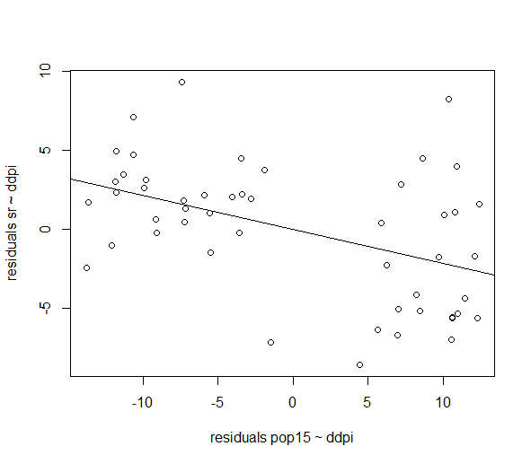
There is a negative relationship between the two sets of residuals which represents the relationship between pop15 and sr adjusted for the relationship between pop15 and ddpi.
We can fit a regression line to the two sets of residuals, the slope of the regression line measures the effect of pop15 on sr adjusted for ddpi. It is equal to the coefficient for pop15 in the regression model that contains both variables.

m_res <-lm(m_ddpi$res ~ m_pop15_ddpi$res)
abline(m_res)
summary(m_res)

Exercise
Create a partial regression plot showing the relationship between ddpi and sr adjusted for pop15.

Hypothesis tests
Let’s start with the full model:

m2<-lm(sr ~ pop15 + pop75 + dpi +ddpi, data = savings)

The output is shown below.
Call:
lm(formula = sr ~ pop15 + pop75 + dpi + ddpi, data = savings)

Coefficients:
Estimate Std. Error t value Pr(>|t|)
(Intercept) 28.5660865 7.3545161 3.884 0.000334 ***
pop15 -0.4611931 0.1446422 -3.189 0.002603 **
pop75 -1.6914977 1.0835989 -1.561 0.125530
dpi -0.0003369 0.0009311 -0.362 0.719173
ddpi 0.4096949 0.1961971 2.088 0.042471 *
---
Signif. codes: 0 ‘***’ 0.001 ‘**’ 0.01 ‘*’ 0.05 ‘.’ 0.1 ‘ ’ 1

Residual standard error: 3.803 on 45 degrees of freedom
Multiple R-squared: 0.3385, Adjusted R-squared: 0.2797
F-statistic: 5.756 on 4 and 45 DF, p-value: 0.0007904

Can you use the output to write down the fitted regression model?
For each coefficient, write down a sentence interpreting the meaning of the coefficient.

Test the hypothesis:
H₀: $β_{1}=β_{2}=β_{3}=β_{4}=0$
H_{A}: at least one of the $β_{i}≠0$
What do the results of the hypothesis test imply for the regression model?

Test the hypothesis:
H₀: $β_{3}=0$
H_{A}: $β_{3}≠0$
What do the results of the hypothesis test imply for the regression model?

Next, let’s test the hypothesis: H₀: ${β_{2}=β}_{3}=0$
H_{A}: ${β_{2}, β}_{3}$ not both equal to 0

To do this we need to compare the fit of the two models

m2<-lm(sr ~ pop15 + pop75 + dpi + ddpi, data = savings)
m3<-lm(sr ~ pop15 + ddpi, data = savings)

The comparison is made using the F- ratio test which tests to see whether there is a significant difference between the fit of the two models. We use the anova command:

anova(m3, m2)

Analysis of Variance Table

Model 1: sr ~ pop15 + ddpi
Model 2: sr ~ pop15 + pop75 + +dpi + ddpi
Res.Df RSS Df Sum of Sq F Pr(>F)
1 47 700.55
2 45 650.71 2 49.839 1.7233 0.19
The result of the F-test test is not significant, therefore we fail to reject the null hypothesis and conclude that the variables pop75 and dpi are not associated with sr (when pop15 and ddpi are included in the model).

summary(m3)
Call:
lm(formula = sr ~ pop15 + ddpi, data = savings)

Coefficients:
Estimate Std. Error t value Pr(>|t|)
(Intercept) 15.59958 2.33439 6.682 2.48e-08 ***
pop15 -0.21638 0.06033 -3.586 0.000796 ***
ddpi 0.44283 0.19240 2.302 0.025837 *
---
Signif. codes: 0 ‘***’ 0.001 ‘**’ 0.01 ‘*’ 0.05 ‘.’ 0.1 ‘ ’ 1

Residual standard error: 3.861 on 47 degrees of freedom
Multiple R-squared: 0.2878, Adjusted R-squared: 0.2575
F-statistic: 9.496 on 2 and 47 DF, p-value: 0.0003438

Collinearity
We noted in class that the coefficient of the variable pop75 varied from model to model depending on which other variables were included in the model. The variation in the coefficient was large enough that the coefficient changed sign. This makes interpretation of the relationship between sr and pop75 unclear. You can observe this for yourself by fitting models containing different combinations of explanatory variables.

We also noted that pop75 and pop15 were negatively correlated with each other since both variables measure the age distribution in a country. The large variation in the coefficient of pop75 is due to collinearity. Collinearity leads to imprecise estimates of β with large standard errors so that t-tests and F-tests fail to reveal significance. Collinearity can be detected by calculating the variance inflation factor (VIF) associated with each coefficient. If the maximum VIF exceeds 5 then this is an indication of serous collinearity between the explanatory variables.
The VIFs associated with each coefficient in a model can be calculated using:

vif(m2)

pop15 pop75 dpi ddpi
5.937661 6.629105 2.884369 1.074309

None of the VIFs associated with the full model exceed 8 but we know from our analysis that including pop15 and pop75 in the same model increases the uncertainty associated with pop75.

Diagnostics
We need to check that the error terms are independently identically distributed where $e_{i}\sim N(0,σ^{2})$. We also want to check for outliers and influential points.
The function lm.influence() provides useful quantities for checking the model fit.

For the model m3:

m3<-lm(sr ~ pop15 + ddpi, data = savings)

First we will check that the error terms are independent by looking for patterns in plots of the residuals. We will plot residuals vs. fitted and residuals vs. explanatory variables.

To calculate the standardized residuals:
stdres <- rstandard(m3)

plot(m3$fitted ~ stdres)

windows(18,8)
par(mfrow = c(1,3))
plot(stdres ~ m3$fitted)
plot(stdres ~ savings$pop15)
plot(stdres ~ savings$ddpi)

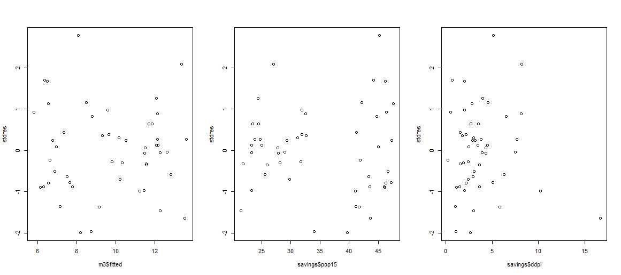
The plot of residuals vs. fitted looks random and shows no sign of heteroscedasticity. In the second plot, the residuals seem to be split into two groups, where one group appears to have a larger variance. In the third plot we note there is possibly an outlier in the variable ddpi. If we check the data, the potential outlier is Libya.

To assess normality, we can look at the qqplot:

windows(10,10)
par(mfrow=c(2,2))
plot(m3)
The residuals look normal.
Next we consider outliers and influential points.
The observation with the largest Cook’s distance is Libya.

We can calculate and then plot the leverages. Recall, the leverage of the i^{th} case can be obtained from the ‘hat’ matrix.

h<- lm.influence(m3)$hat
plot(h, xlab = “Country”, ylab = “leverage”)

Recall, a rule of thumb is that leverages of more than $\frac{2(k+1)}{n}$ should be looked at more closely, where k+1 represents the number of parameters in the model and n represents the number of observations. In this case there are three parameters in the model so we need to check that $h_{i}=\frac{6}{50}=0.12$
We can plot the line y = 0.12 onto our plot and then identify points with a leverage greater than this value using the identify() function which allows us to identify points on the graph using the mouse.

abline(h=0.12)
identify(h,n=2)

We see that Libya is an observation with high leverage and possibly Jamaica.
Let’s fit the regression model without Libya and see how it impacts the model.

m4 <-lm(sr ~ pop15 + ddpi, data = savings[-49,])

Call:
lm(formula = sr ~ pop15 + ddpi, data = savings[-49, ])

Coefficients:
Estimate Std. Error t value Pr(>|t|)
(Intercept) 13.92873 2.49792 5.576 1.24e-06 ***
pop15 -0.19398 0.06069 -3.196 0.00252 **
ddpi 0.72451 0.25269 2.867 0.00623 **
---
Signif. codes: 0 ‘***’ 0.001 ‘**’ 0.01 ‘*’ 0.05 ‘.’ 0.1 ‘ ’ 1

Residual standard error: 3.788 on 46 degrees of freedom
Multiple R-squared: 0.3284, Adjusted R-squared: 0.2992
F-statistic: 11.25 on 2 and 46 DF, p-value: 0.0001056

We see that the coefficient for ddpi has nearly doubled. It is worrying if the coefficients are this sensitive to the presence of just one observation.
The lm.influence() function can calculate the changes to the estimated coefficients due to dropping each observation in turn.
changes<-lm.influence(m3)$coefficients

We can plot the changes to the coefficients:

plot(changes[,2], ylab = "changes to the coefficient for pop15")
plot(changes[,3], ylab = "changes to the coefficient for ddpi")

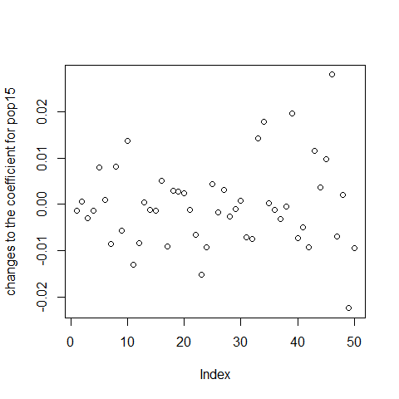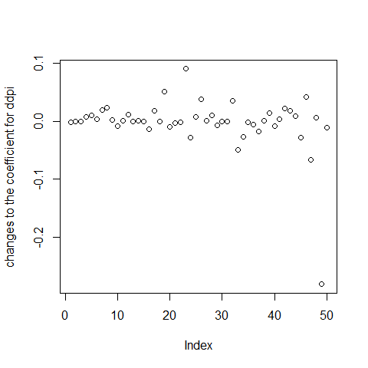

We see that Libya has the largest impact on the coefficients.

How well does the model generalize?
If our model is to be used for the purposes of prediction, then to understand how well our model will perform on unseen data, ideally we need an independent test set on which to test the predictive accuracy of the fitted model. Unfortunately, we are often constrained by sample size, however re-sampling methods can measure how well our model performs with unseen data and whether our model suffers from overfitting. If out model is to be used to interpret effect estimates and for hypothesis testing, we may not be concerned with the model’s predictive accuracy on unseen data, however, we may wish to check for overfitting and examine the sensitivity of the parameter estimates to the data used to fit the model.
Two popular re-sampling methods include k-fold cross validation and bootstrapping; both of which can be carried out using the caret package.

Exercise
The gamb.csv dataset is available on Canvas. The dataset is from a study of gambling in Britain. The variables are:
• sex: 0 = male, 1 = female
• status: socioeconomic status score based on parents’ occupation
• income: in pounds per week
• verbal: verbal score in words out of 12 correctly defined
• gamble: expenditure on gambling in pounds per year

The aim of the exercise is to find out which (if any) of the variables status, income and verbal are of use in predicting the value of gamble.

- Make a numerical and graphical summary of the data, commenting on the results. Include: boxplots, histograms, scatterplots and correlation coefficients.
- Fit the model : ${y=β}_{0}+β_{1}status+{β_{2}income+β}_{3}verbal+e$
- Interpret the coefficient for income.
- Calculate the variance inflation factors for this model and discuss their implications for collinearity in the model.
- Test the hypothesis:
H₀: $β_{1}=β_{2}=β_{3}=0$
H_{A}: at least one of the $β_{i}≠0$
What do the results of the hypothesis test imply for the regression model?
- Test the hypothesis:
H₀: $β_{3}=0$
H_{A}: $β_{3}≠0$
What do the results of the hypothesis test imply for the regression model?
- Assess the fit of the model using diagnostic plots and try to improve the fit of the model.

